## **Use Case** **diagram**

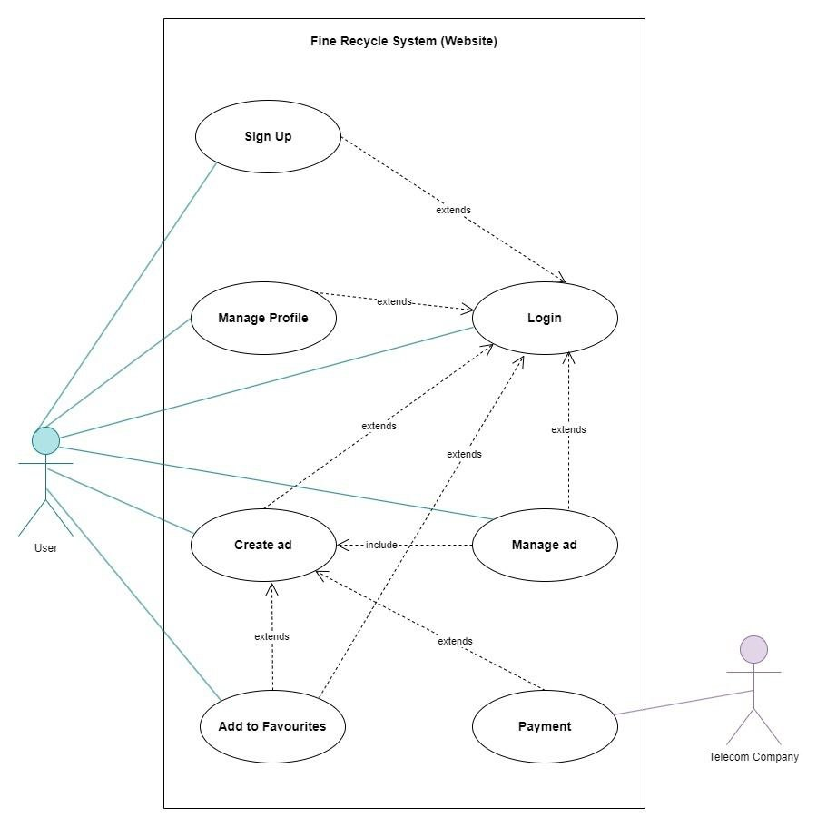

Figure 1 Use case Part1

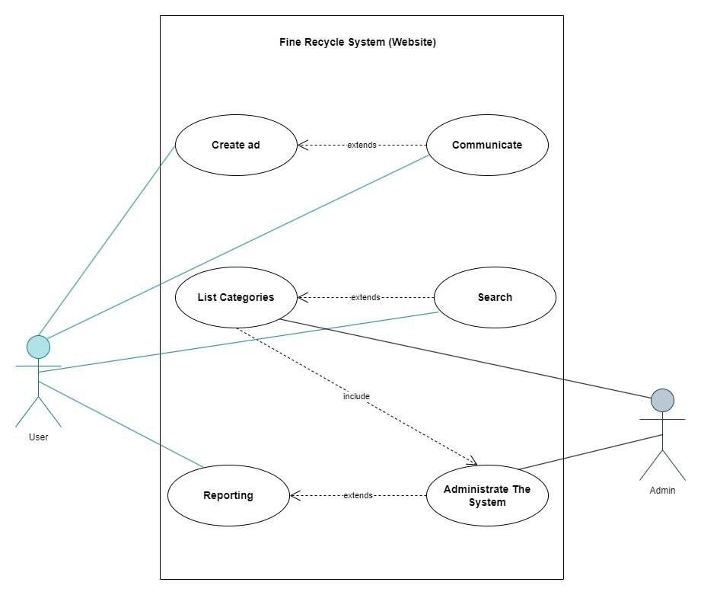

Figure 2 Use case part2